SABPA OC/LA
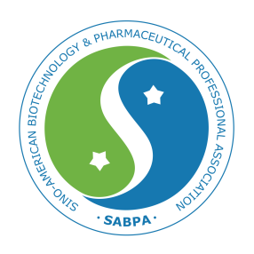
(Sino-American Biotechnology & Pharmaceutical Professionals Association, Orange County/Los Angeles)

2nd DISCOVERY AND ENTREPRENEURSHIP EVENT
January 20, 2017, Irvine, CA
PRESENTER

When

January 20 (Sat), 2018
7:30 PM – 9:00 PM

Where
Irvine Ranch Water District
15500 Sand Canyon Ave.,
Irvine, CA 92618

Free Registration
https://goo.gl/mQ5amR
Registration is free but required one day before event to limit to the first 70 registrants. Parking is free.

Questions
Go to http://www.sabpa-ocla.org
Email Sabpa.ocla@gmail.com
Jin Luo, Ph.D., is President and co-founder of Irvine Chemistry Lab since 2008. Dr. Luo received his Ph.D. degree in chemistry from Purdue University in 1997. Since then, he was involved in development of anti-cancer delivery system in Endocyte, synthesis of pharmaceutical ingredients in Johnson Matthey, and cGMP production of immunoassay kits in Beckman-Coulter. His current interests include synthesis of bio-molecules, development of cross-linking strategies, invention of novel bio assay kits and molecular probes.
The Presentation
Development of Novel Protein Assay Kit for Total Protein Quantitation
---Other potential applications such as in detection of melamine (三聚氰胺) in dairy products
SABPA is an 501(c)(3) nonprofit organization
Jin Luo, Ph.D.
President and co-founder, Irvine Chemistry Lab

