Sino-American Biomedical and Pharmaceutical Professional Association

Orange County / Los Angeles Chapter
Presents
Thirteenth Annual Biomedical Forum
Innovation and Development
–-- From Engineer to Business

April 21, 2018

Double Tree by Hilton Hotel
201 E MacArthur Blvd
Santa Ana, CA 92707
www.sabpa-ocla.org

Editor: Ling Lin and Fred Ouyang
Print: Bin Tian
Design: Xinxin Wu
© SABPA OC/LA
April 21, 2018

Thirteenth Annual Biomedical Forum

Welcome, and thank you for joining SABPA at its 13th Annual Biomedical Forum, the flagship event organized by SABPA OC/LA Chapter. This exciting forum is devoted to providing an attractive platform for entrepreneurs, scientists, investors, executives, and students to get involved in promoting life sciences and biotechnology, and in stimulating alliances across the biomedical industry and related fields in Southern California and Pacific Asia.
This year's forum will bring you the latest innovations in biomedical industries, cutting-edge developments of pharmaceuticals and medical devices, entrepreneurship and fundraising for startups, and career development through its various activities.
- Keynote Speeches and Presentations, covering diverse topics such as antibacterial drug discovery/development, culture and innovation in life science, advances in optical coherence tomography (OCT) from bench to bedside, innovation and entrepreneurship in life sciences, and labeling compliance, regulatory considerations of medical devices;
- Panel Discussion, eliciting perspectives of creative fundraising and investment for startups, sharing fundraising experience and knowledge in life sciences and biomedical industries;
- Sponsor Show, featuring Sponsors providing products, services, and technologies that benefit the SABPA community;
- Career Development Roundtable, providing the networking opportunity to graduate students and professionals for open and engaged conversations with peers in life science to learn about their diverse career paths and experiences, to gain insights and advice for career development, and to build future relationships with peers.
I strongly encourage all attendees to take the opportunity to learn from these important presentations, delivered by renowned experts in the field. Thank you again for joining SABPA’s 13th Annual Biomedical Forum to share your knowledge, exchange ideas, and form collaborations to advance life sciences, biotechnology, and alliances across the biomedical industry in Southern California and Pacific Asia.
I would like to thank the SABPA OC/LA committee members and volunteers for their hard work and dedication, our speakers and panelists for sharing their practical experience, our sponsors for their generosity, and your participation in making our forum successful. I invite all of you to get involved and help SABPA in its future development and growth. I hope today’s forum will be an engaging, educational, and fruitful experience for all of us.

Huaina Li, Ph.D., DABT
President, SABPA OC/LA
Program

8:30-9:00 AM | Breakfast and Registration
 | Opening: Ling Lin, Ph.D., Chair of Communication Committee, SABPA, OC/LA
9:00-9:05 AM | Welcome
 | Huaina Li, Ph.D., DABT, President, SABAP OC/LA
 | Morning Section
 | Chair, Jie Shen, Ph.D., Chair of Membership Development Committee SABPA OC/LA
9:05-9:50 AM | Ian Critchley, Ph.D., VP of Clinical Microbiology, Allergan  Keynote Presentation:
 | “The Roller Coaster of Antibacterial Drug Discovery and Development in an Era of Increasing Resistance”
9:50-10:20 AM | Raymond W. Brullo, DPM, Ph.D., Compliance Officer, FDA Irvine Office  Presentation: “Labeling Compliance- Advertising & Promotion of Medical Devices-Regulatory Considerations”
10:20-10:50 AM | Coffee break, Exhibit & Networking
10:50-11:20 AM | Zhongping Chen, Ph.D., Professor of Biomedical Engineering and Director of the OCT Laboratory at UCI Presentation: “Advances in Optical Coherence Tomography: Translation of OCT Technology from Bench to Bedside”
11:20-11:50 AM | Sponsor Presentation and Appreciation:  Qing Zhou, Ph.D., Chair of Funding Raising Committee SABPA OC/LA
11:50-1:25 PM | Lunch break, Exhibit & Networking  Career Development Roundtable Discussion Moderator, Jie Shen, Ph.D., Chair of Membership Development Committee SABPA OC/LA
Afternoon Section
Chair, Bruce Liu, Ph.D., President, ACB SciTech, Inc.
1:25-2:10 PM | Cun-Yu Wang, D.D.S., Ph.D., Professor, Chair, UCLA, Member of National Academy of Medicine  Keynote Presentation:  “Chinese Culture, Innovation and Beyond”
2:10-2:40 PM | Jianlu Ma, CEO/President, Neurovasc Technologies Presentation: “Engineer Minds vs Business Minds”
2:40-3:10 PM | Shouyan Lee, Ph.D., Founder and CTO, Joy Medical and Medical Implant  Presentation: “From Starr-Edwards Ball valve to TMVR: More than half century of innovation in devices treating heart valve diseases”
3:10-3:30 PM | Coffee break, Exhibit & Networking
3:30-4:50 PM | Panel Discussion: “Fundraising for Startup”
 | Moderator, Guangqiang Jiang, Ph.D., CTO & co-founder, Axonics Modulation Technologies, Inc.
 | Panelists:
Jinsong Ni, Ph.D., CEO & CSO, Cloudbreak Therapeutics
Libin Cui, Ph.D., Founder and CEO, Akeagen
Eric Tang, Ph.D., Chairman, ZD Medical
Guorong Xu, Ph.D., Vice President, Innomed Medical Device
Wendy Hua, Ph.D., Managing partner, Cybernaut US venture capital funds
4:50 PM | Closing Remarks
 | Kevin Shao, MBA, EVP, SABPA OC/LA

Speaker Biographies
(In the order of presentation)
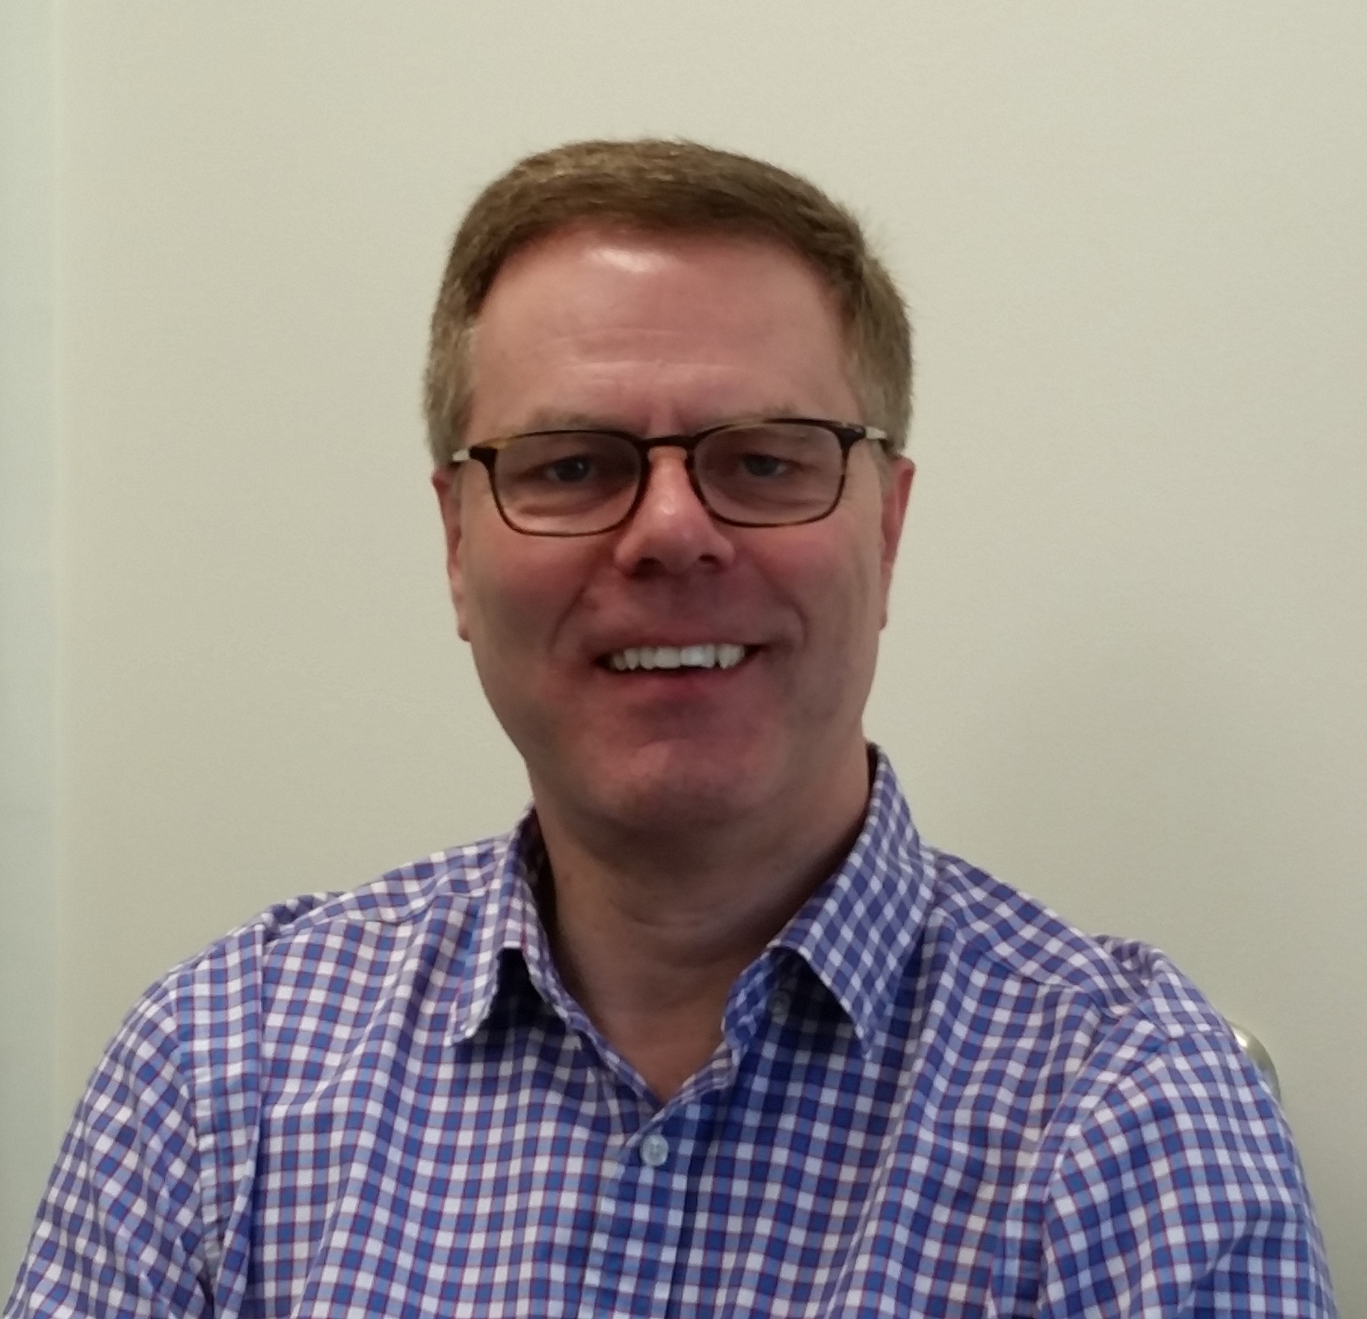 | Ian Critchley, Ph.D.  VP of Clinical Microbiology  Allergan
Dr. Ian Critchley is currently the Vice President of Clinical Microbiology at Allergan which is a global pharmaceutical company focused on developing treatments for serious and life-threatening infections as one of its key therapeutic areas. Dr. Critchley obtained his PhD in Microbiology at the University of Glasgow, Scotland UK and has more than 30 years of experience in both antibacterial discovery research and development. Dr. Critchley started his career at SmithKline Beecham. After 10 years there, he joined Focus Technologies as Director of Laboratory Services. He then served as Executive Director of Microbiology at Replidyne for 5.5 years. Prior to joining Allergan, he was Vice President of Clinical Microbiology at Cerexa for 6.5 years before its acquisition by Actavis. Dr. Critchley has published over 70 peer-reviewed journal articles on the topic of microbiology and anti-infective drug development. Dr. Critchley is a member of the American Society for Microbiology, the U.K. Society for General Microbiology and the British Society for Antimicrobial Chemotherapy. In recent years Dr. Critchley’s team has managed pre-clinical and clinical microbiology studies to characterize the profiles of three approved antibiotics including; Teflaro® (ceftaroline fosamil) which was the first and only -lactam to be approved in the US, Avycaz® (ceftazidime combined with avibactam, a novel non--lactam -lactamase inhibitor) which is active against resistant Gram-negative pathogens, and Dalvance® (dalbavancin), a long acting glycopeptide antibiotic. Today Dr. Critchley’s team at Allergan continues to support antibacterial products that address existing and emerging resistance mechanisms.

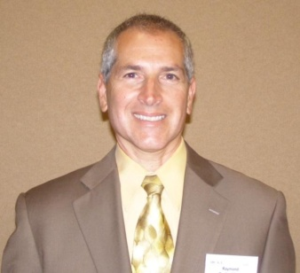 | Raymond W. Brullo, DPM, Ph.D. Compliance Officer  FDA Irvine Office
Dr. Raymond W. Brullo, DPM, Ph.D., is a compliance officer in the Food Drug Administration/Office Regulatory Affairs/Office Medical Devices Radiological Health Operations. Dr. Brullo reviews inspectional and investigational medical device case evidence for assessment of regulatory status and potential enforcement action. Dr. Brullo is a retired Podiatric physician & surgeon having practiced in the Chicago, Illinois area from 1983-2002. He graduated from Podiatric medical school in 1983 and served a surgical internship in Iowa from 1983-1984. His specialization was in wound care, lower extremity infections, and treatment and prevention of diabetic-related pathologies.

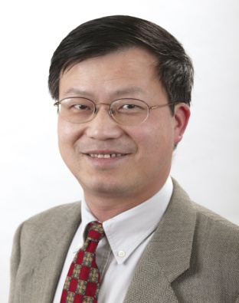 |  | Zhongping Chen, Ph.D.  Professor, Director.  UCI
Dr. Zhongping Chen, Ph.D., is a Professor of Biomedical Engineering and Director of the OCT Laboratory at the University of California, Irvine. He is a Co-founder and Chairman of OCT Medical Imaging Inc. Dr. Chen received his B.S. degree in Applied Physics from Shanghai Jiao Tong University in 1982, his M. S. degree in Electrical Engineering in 1987, and his Ph.D. degree in Applied Physics from Cornell University in 1993.
Dr. Chen’s research interests encompass the areas of biomedical photonics, microfabrication, biomaterials and biosensors. His research group has pioneered the development of functional optical coherence tomography, which simultaneously provides high resolution 3-D images of tissue structure, blood flow, and birefringence. These functional extensions of OCT offer contrast enhancements and provide mapping of many clinically important parameters. In addition, his group has developed a number of endoscopic and intravascular rotational and linear miniature probes for OCT and MPM imaging and translated this technology to clinical applications. He has led numerous major research projects funded by NIH, NSF, DOD, and DARPA, including several interdisciplinary research projects such as the NIH Biomedical Research Partnership (BRP) grant and NSF Biophotonics Partnership Initiative grant. Currently, he is the principal investigator of Four NIH R01 grants. He has published more than 250 peer-reviewed papers and review articles and holds a number of patents in the fields of biomaterials, biosensors, and biomedical imaging.
Dr. Chen is a Fellow of the American Institute of Medical and Biological Engineering (AIMBE), a Fellow of SPIE, and a Fellow of the Optical Society of America.
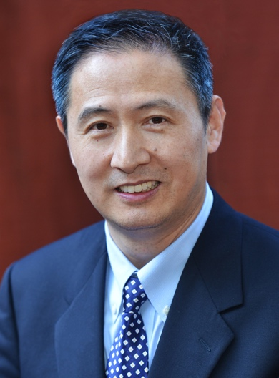 | Cun-Yu Wang, D.D.S., Ph.D.  Professor, Chair, UCLA  Member of National Academy of Medicine
Dr. Cun-Yu Wang, D.D.S., Ph.D., is the No-Hee Park Endowed Professor and Chair in Division of Oral Biology and Medicine, the Associate Dean for Graduate Studies, School of Dentistry, UCLA. He has made a landmark discovery on the regulation of cancer cell death by the transcription factor NF-κB, which was cited as one of ten important discoveries in 1996 by Science magazine. He was elected to the National Academy of Medicine as a member in 2011 and to the Chinese Academy of Engineering as a foreign member in 2013.

Jianlu Ma, CEO & President
Neurovasc Technologies
Mr. Jianlu Ma founded Neurovasc Technologies Inc. in August of 2015, with a unique background in serial medical device development, clinical evaluation, and commercialization experience.
Prior to starting Neurovasc, Mr. Ma founded Marvel Medical Technologies in 2011 and served as its General Manager and also worked with several major medical device companies and managed R&D activities in the last 22 years.
Mr. Ma received a Bachelor of Arts from Xi’an Technological University and his Masters of Science Degree from Florida International University. Mr. Ma has 23 issued US patents and over 46 US patent applications related to vascular devices.

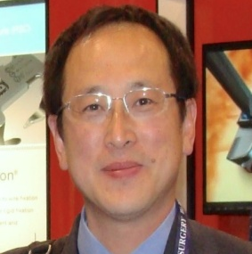 | Shouyan Lee, Ph.D.  Founder and CTO  Joy Medical and Medical Implant
Dr. Shouyan Lee, Ph.D., is the founder and Chief Technology Officer of Joy Medical and Medical Implant Testing Lab. Dr. Lee has been working in cardiovascular devices industry, mainly on prosthetic heart valves since 1982. He has designed 5 different testers for prosthetic heart valves and 6 prosthetic valve products, most of them have been commercialized. Dr. Lee also holds position in work group on heart valve related ISO standard, and committee member in Chinese valve standard committee.

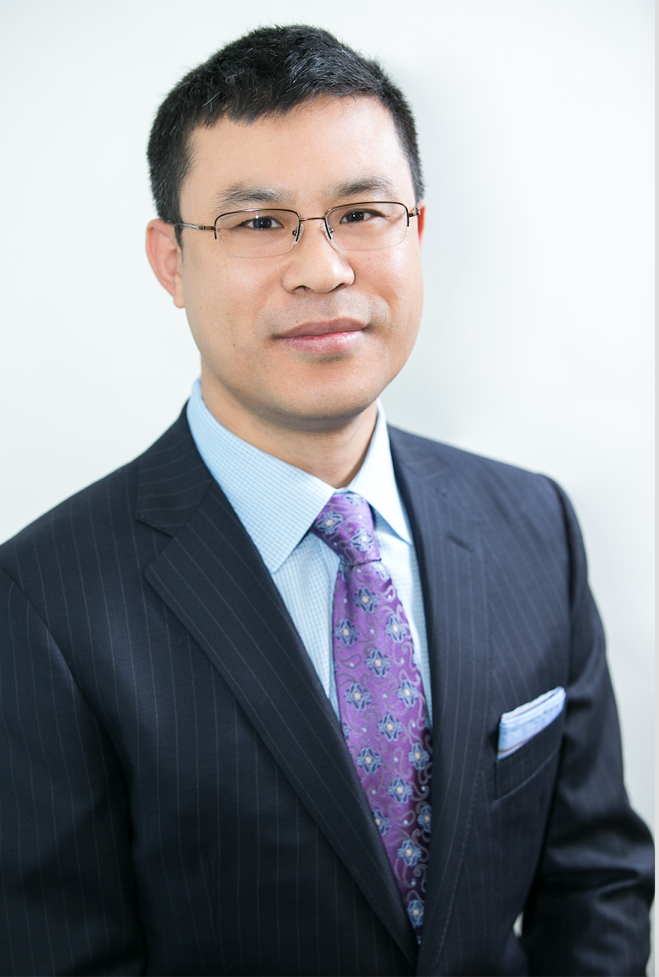 |  | Guangqiang Jiang, Ph.D.  CTO & co-founder  Axonics Modulation Technologies Inc.
Dr. Guangqiang (Jay) Jiang, Ph.D., is Chief Technology Officer and co-founder of Axonics Modulation Technologies, Inc., a venture capital backed company, which is developing a platform miniaturized neuromodulation system for Urinary and Bowel dysfunction. He holds twenty-six issued US patents and about a dozen international counterparts, with additional patent applications pending. Dr. Jiang is a seasoned technical executive with a solid track record of developing complex, implantable Class III medical devices. He was previously VP of R&D at the Alfred Mann Foundation. Dr. Jiang was elected to College of Fellows of the American Institute for Medical and Biological Engineering (AIMBE) and served as Principal Investigator on several government contracts funded by DARPA and NIH. Dr. Jiang graduated from Tsinghua University, Beijing, China and holds a Ph.D. in Biomedical Engineering from the University of Southern California.

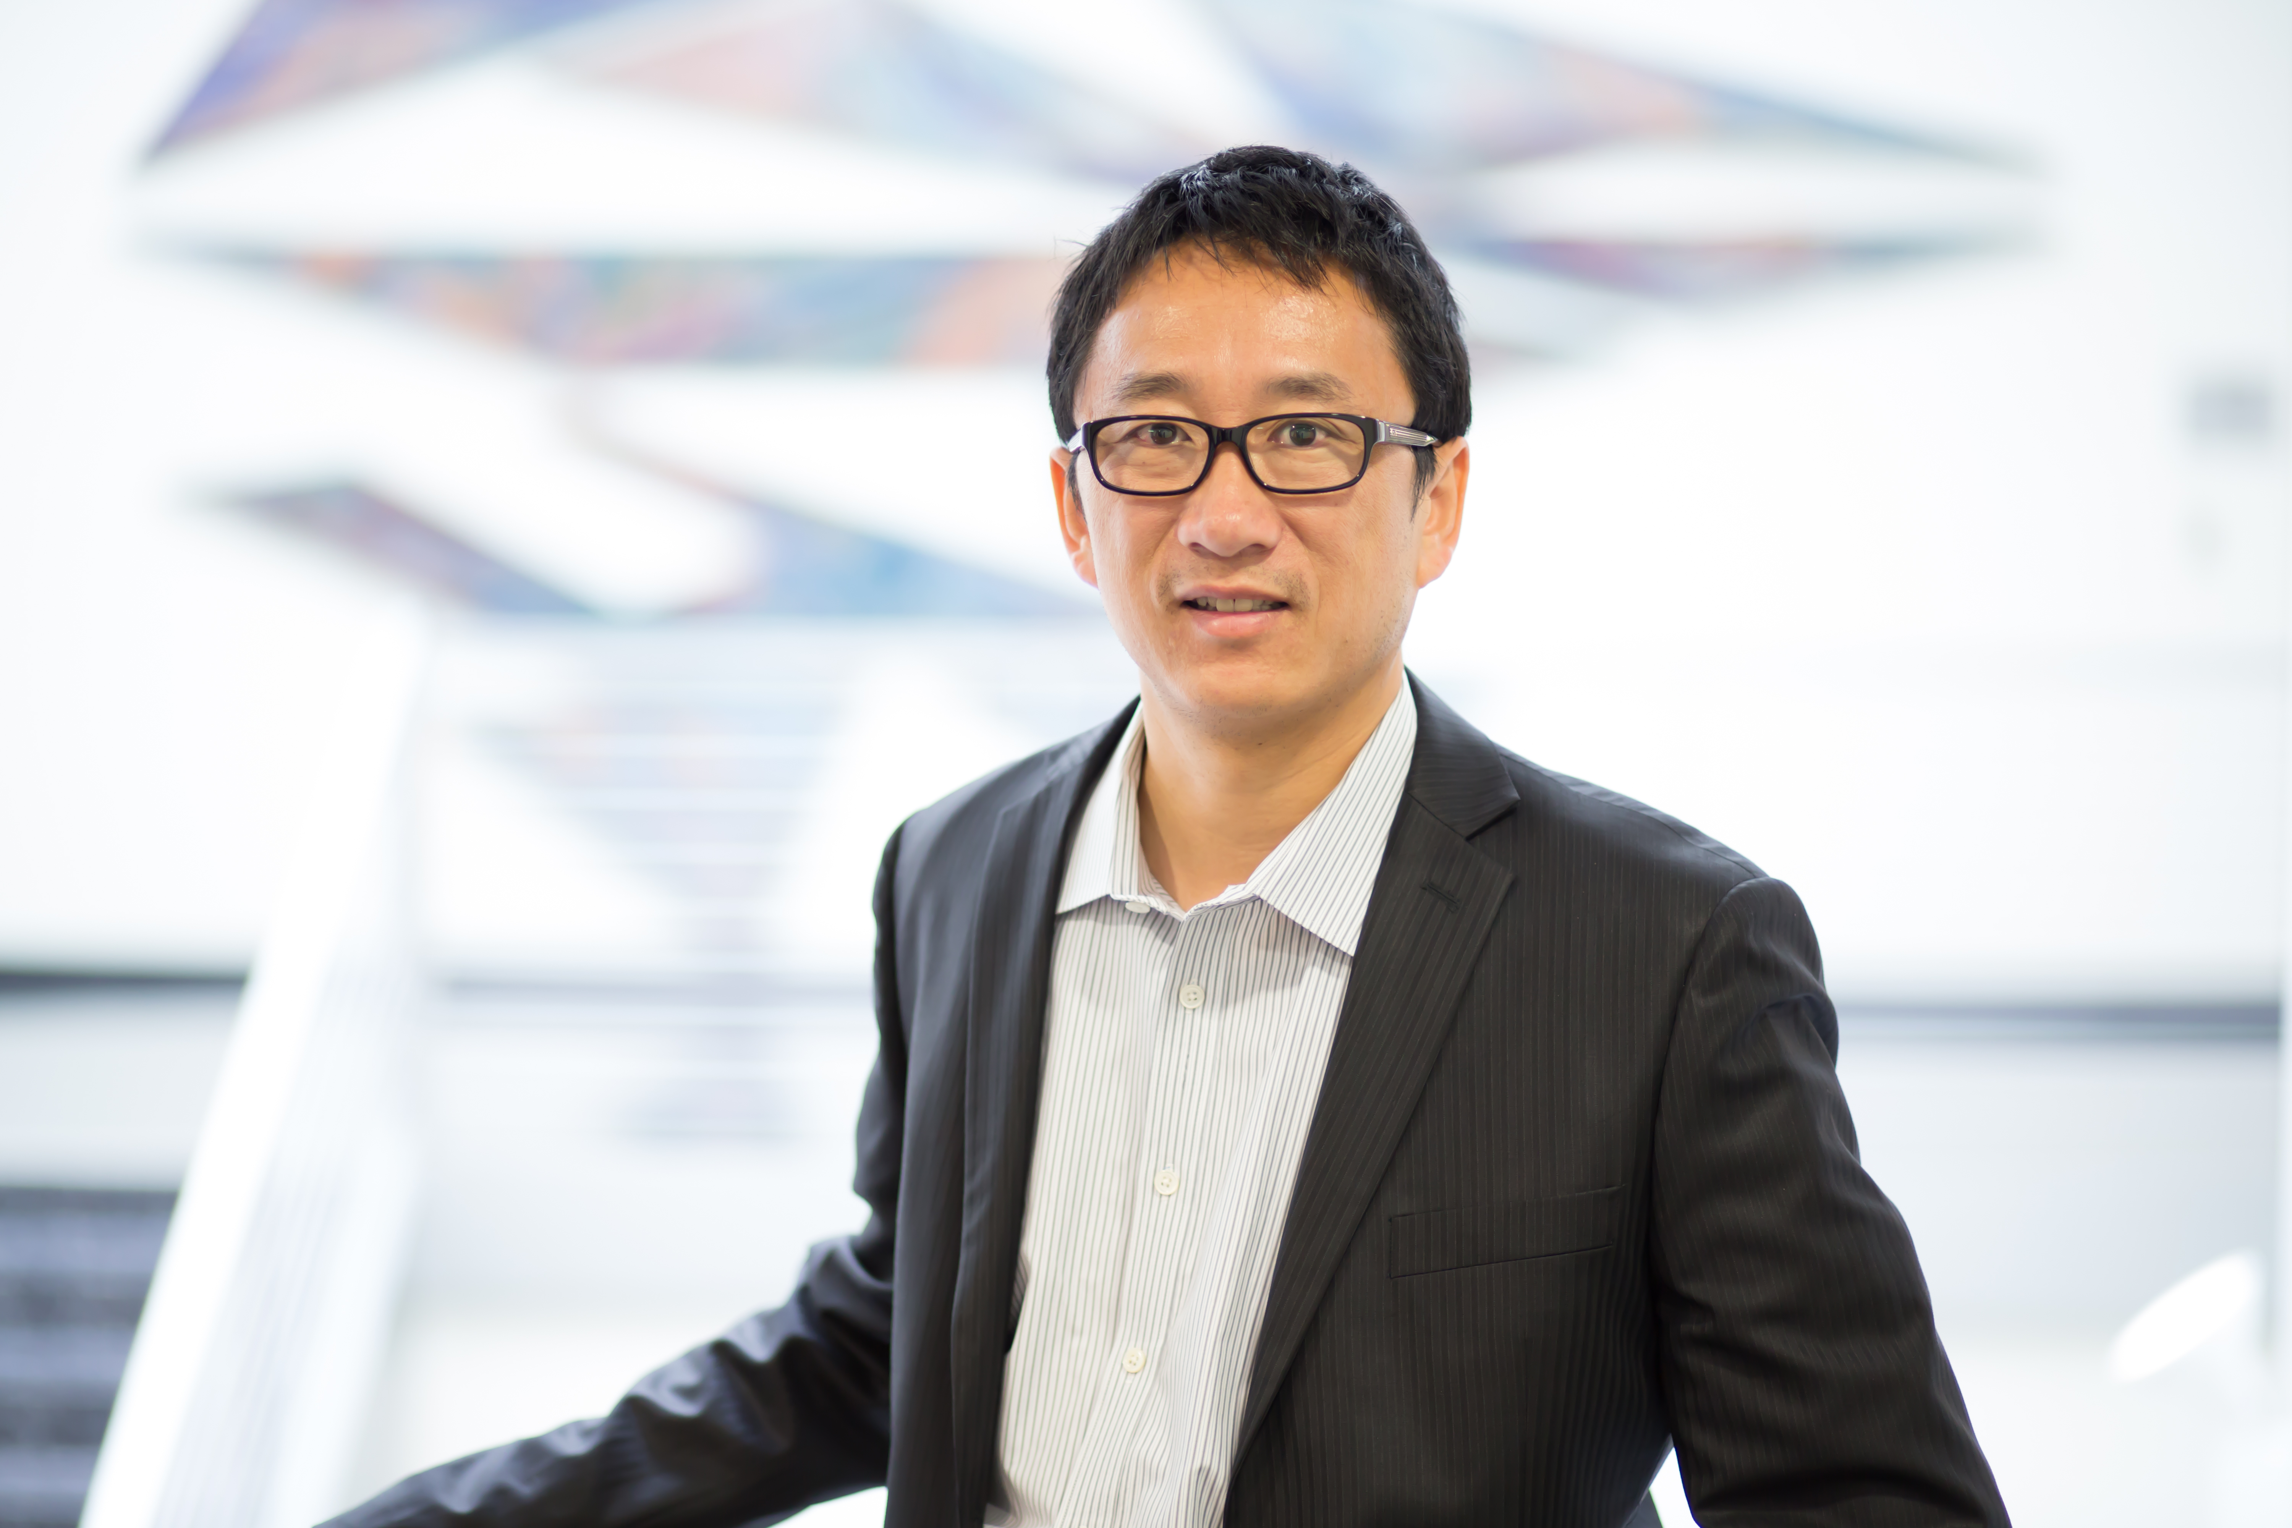 |  |  | Jinsong Ni, Ph.D.  CEO &CSO,  Cloudbreak Therapeutics
Dr. Jinsong Ni, Ph.D., is currently the Founder, CEO and CSO of Cloudbreak Therapeutics, a startup company founded in Irvine in September, 2015. Dr. Ni has over twenty years of pharmaceutical industry and academic research experiences in drug discovery and drug development. He has participated as a member of project teams for the successful launch of many ocular and dermal products at Allergan and Wyeth (Pfizer). Dr. Ni also serves as non-clinical sub-team lead and compound manager to advance drug candidates to various development stages including IND and NDA submission for small and large molecule drugs across multiple therapeutic areas including CNS (neuropathic pain), ophthalmology (glaucoma, ocular surface disease and retinal disease) and dermatology (actinic keratosis, acne, rosacea), women health, oncology and infectious disease.
Dr. Ni currently is a Board member and Vice Chair of Sino-American Biotechnology and Pharmaceutical Professional Association (SABPA) and has previously served as President of SABPA Orange County / Los Angeles Chapter (2015-2016).
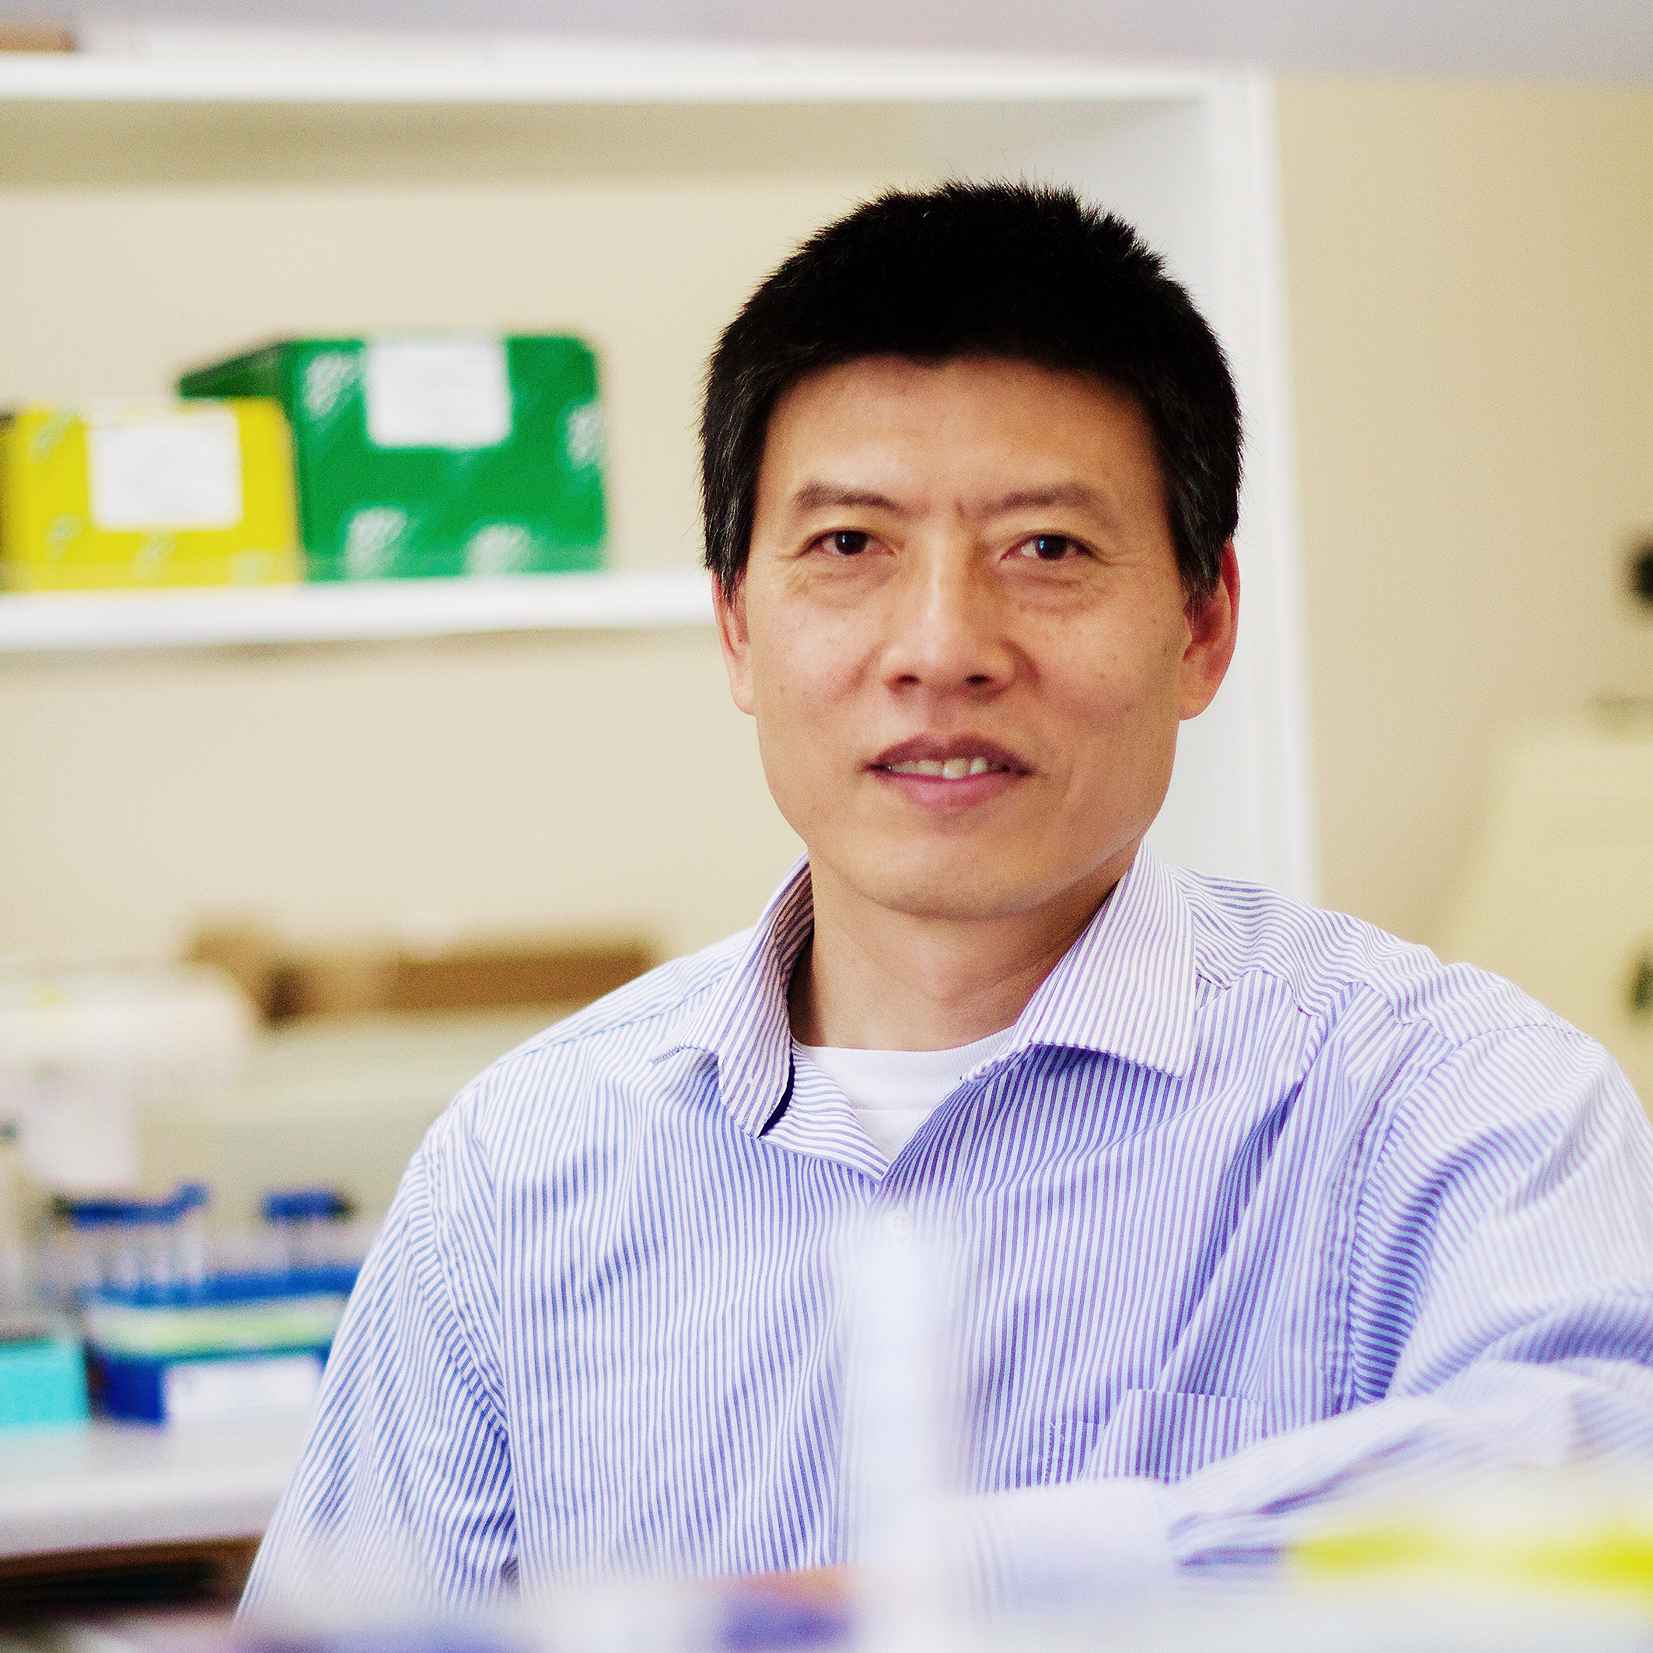 | Libin Cui, Ph.D.  Founder and CEO, Akeagen
Dr. Libin Cui, Ph.D., is CEO and Founder of Akeagen Inc (www.akeagen.com), an Irvine-based biotechnology company focusing on developing next generation therapeutic antibodies for immuno-oncology and immunological diseases. He was the inventor of mouse single domain antibody technology - Akeagen CaMouse Platform, the world’s first genetically-modified mouse that can efficiently generate mouse single domain antibody with superior properties for the development of bispecific antibodies and CAR-T immunotherapy. Prior to Akeagen, he was a senior scientist at Zymo Research Corporation where he led the development of technologies in next generation sequencing analysis of epigenetics modification of human genome. Between 2009-2012, he was Principle Investigator of GSK, Shanghai, China, and then was appointed as Assistant Professor of Medicine at University of Nebraska Medical Center and Boston University Medical School. He received his Ph.D. in Medicine and Molecular Genetics from Chinese Academy of Military Medical Sciences in 1995 and was faculty member of Beijing Institute of Biotechnology. Between 2003 and 2009, Dr. Cui was a Research Fellow and Instructor at Harvard Medical School and Massachusetts General Hospital. He has authored and co-authored highly cited research papers in top journals including Cell and Nature Medicine and was inventors of several patents.
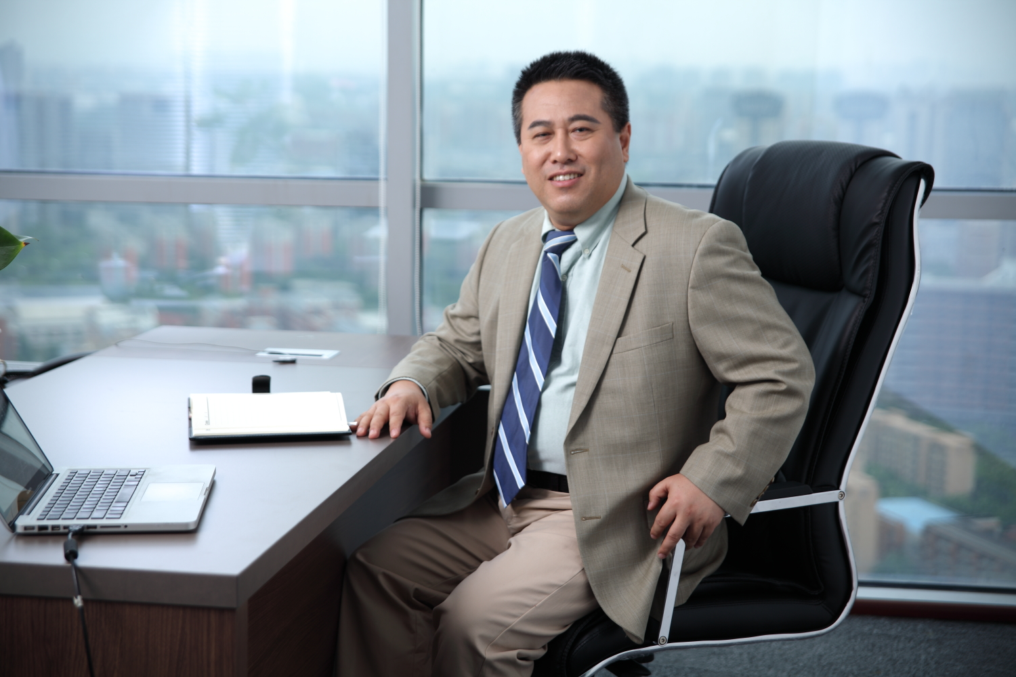 |  | Eric Tang, Ph.D., J.D.  Chairman, ZD Medical
Dr. Tang, Ph.D., J.D., is the Chairman and a co-founder of ZD Medical, a medical device company focusing on providing medical imaging as well as ophthalmic solutions to addressing unmet healthcare needs. Dr. Tang is also a Managing Partner of TitanMed Capital, an international healthcare venture capital firm with offices in Beijing and Hangzhou. The firm, together with its strategic partner, TigerMed, provides funding and industry resources to emerging companies focused on medical devices, biotechnology, and healthcare services. In addition, Dr. Tang was a Managing Partner of Shenzhen Gaotejia Investment Group ("GIG") and the President of Nanjing Gaotejia Healthcare Investment LLP, responsible for managing GIG's oversee investment platform. GIG is one of the top PE firms in China, managing over 20 billion of RMB in assets. During the last couple of years, Dr. Tang and the funds have made a number of investments in the Los Angeles area, including, such as, Blockade Medical, Neural Analytics, and Varocto. Dr. Tang also managed the acquisition of Dendreon, a cancer immunotherapy company located at Seal Beach, by Chinese buyers for US$819M, the largest investment from China in the pharmaceutical area in the U.S.
Dr. Tang holds a Ph.D. degree in Biochemistry and Cell Biology and a J.D. degree, and worked for many years as a patent attorney for major law firms in the U.S. before co-founded ZD Medical.

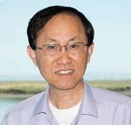 |  | Guorong Xu, Ph.D.  Vice President  Innomed Medical Device
Dr. Guorong Xu, Ph.D., is the Vice President of SuZhou Innomed Medical Device Co.
His other experiences are as follows:
Associate Director, Quality Control, Relypsa Inc. (2015-2016)
Sr. Manager of Quality Control, P.L. Development, Inc. (2013-2015)
Sr. Manager of Quality Control-Chemistry, B. Braun Medical, Inc. (2007-2013)
Sr. Manger of Quality Control, Spectrum Chemicals (2005-2007)
Research Scientist, Sr. Research Scientist, and Manager, Baxter/BioScience (1998-2005)
Research Associate IV, Research Assistant Professor, UCLA Medical School (1996-1998)
National Institute of Health Research Follow, University of South California (1994-1996)
Post-Doctoral Researcher, Program of Molecular and Cellular Biology, University of California, Santa Barbara (1992-1994)
Teaching Assistant and Lecturer, China Pharmaceutical University (1982-1986)
Ph.D., Biochemistry and Analytical Chemistry from South Dakota State University (1992)
B.S., Pharmaceutical Sciences China Pharmaceutical University (1982)

Wendy Hua, Ph.D.
Managing partner
Cybernaut US venture capital funds
Dr. Wendy Hua, Ph.D., managing partner of Cybernaut US
venture capital funds, with over 40 portfolio companies.
Dr. Hua has more than 10 years of entrepreneurial and investment
experiences with focus on finance, technology and healthcare
industries.

华文，博士，赛伯乐海外基金管理合伙人，所管理的基金在美国投资了超过40个高科技初创企业。十年以上创业及投资经验，重点关注金融科技、健康医疗行业.
Sponsors
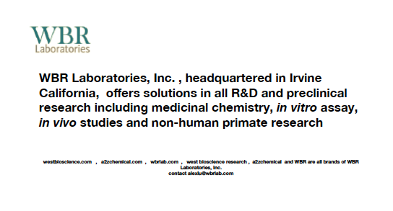

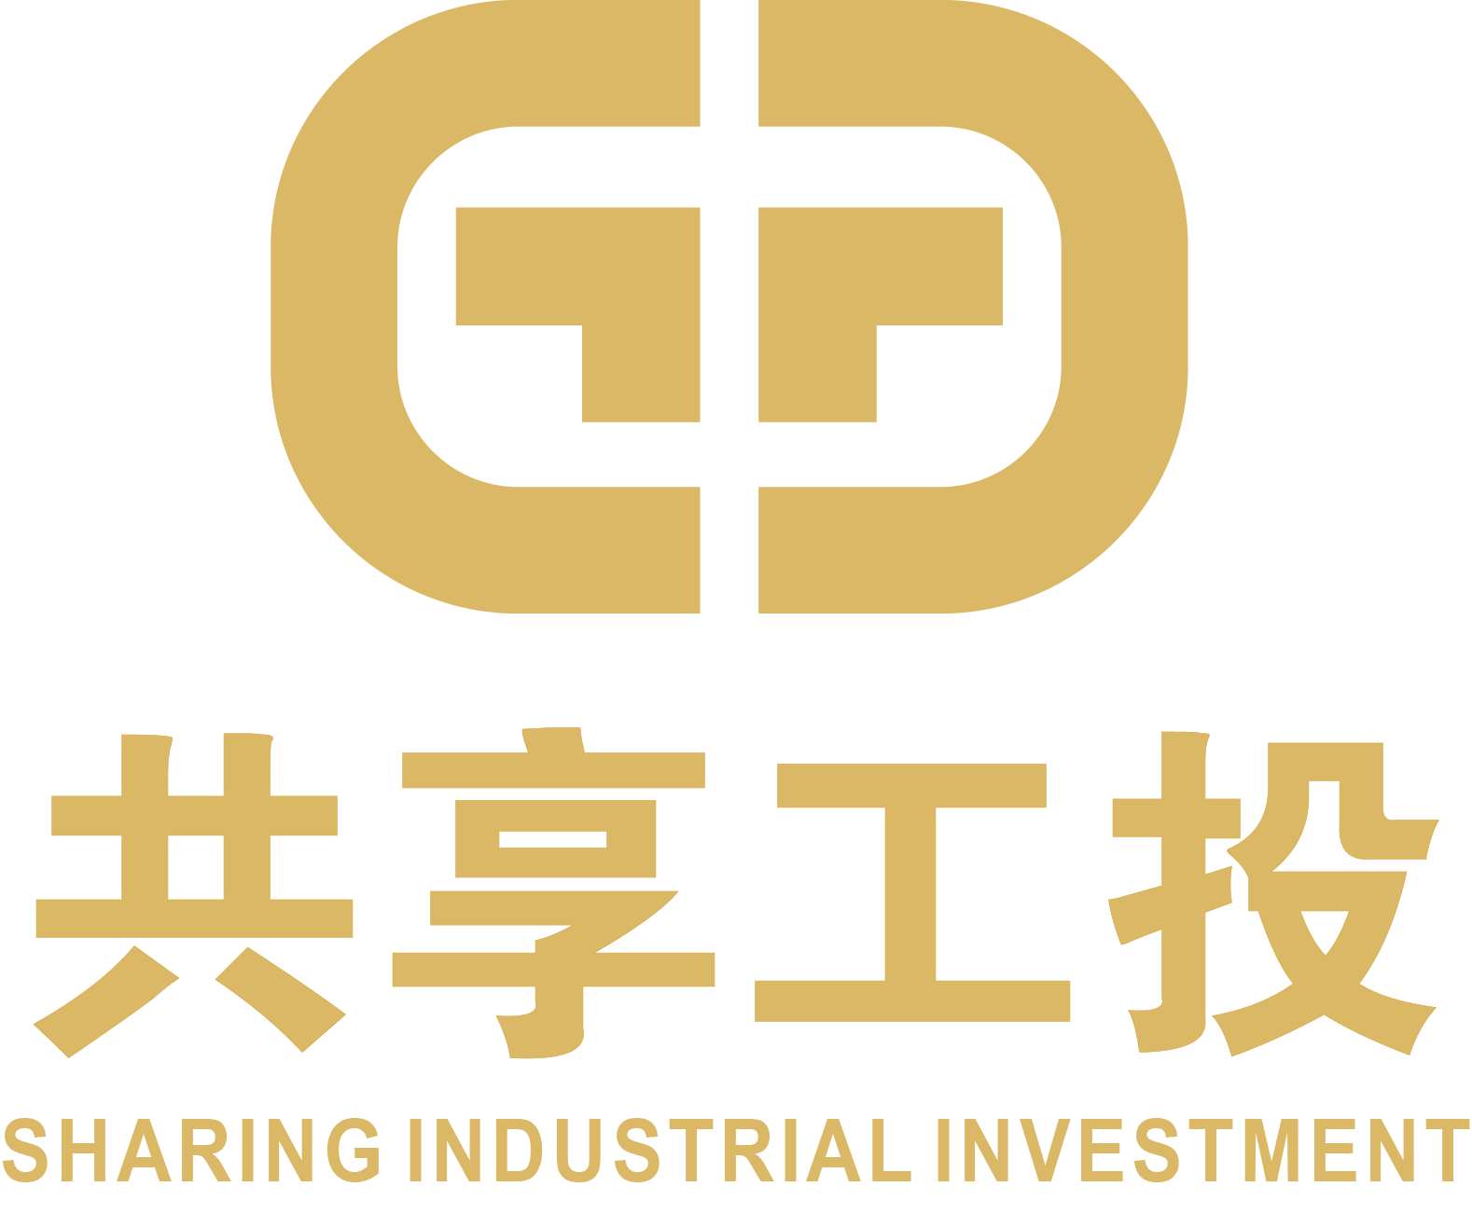

The deployment of Chongqing Science and Technology Innovation City is an important step of Chongqing city’s ambition to build an innovation base, a high-end manufacturing base, and an entrepreneurial homeland for talents at home and abroad. Sharing Industrial Investment and Chongqing University are working together towards this goal.

Professor Yun He, Dean of school of pharmacy at Chongqing University will attend the SABPA 13th Annual Biomedical Forum to meet with friends who are interested in learning more about Chongqing Science and Technology Innovation City.
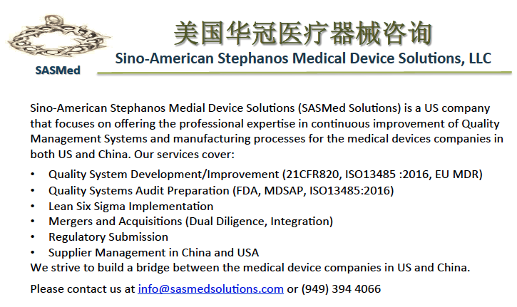
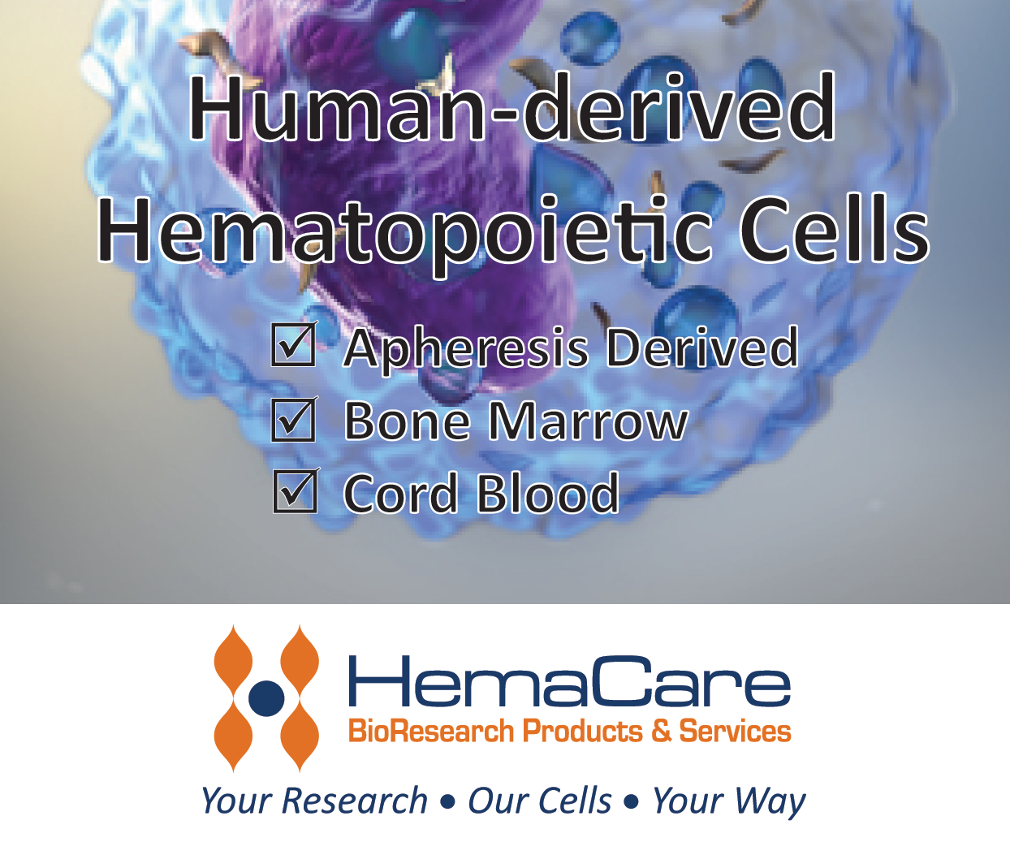
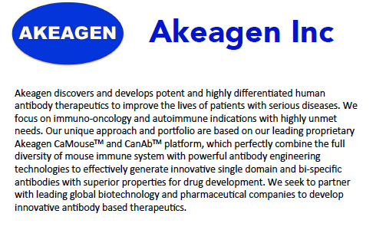
Changzhou Huajian Pharmaceutical Packaging Materials Co., Ltd. (Stock Code: 871016) is a state certified high-technology enterprise, specialized in the production of medicine packaging materials for 15 years and is equipped with a 5,000 square-meter Grade D clean room and 12 certified pharmaceutical packaging materials of direct skin contact approved by CFDA with an annual production capacity over 5000 tons. Also, the whole company has passed through the FDA, ISO 9001, and GMP certification. The company has more than 200 customers across the country including 7 of the Top 10 Chinese Parma companies and has sustained a growth rate of 15% each year. To better serve USA customers, Huajian US Services, established in United State in 2017. Our US team has extensive experience in this area and proudly offer customized solutions to our clients. Address: 19800 MacArthur Blvd, Ste 420, Irvine, CA92612. Learn more at http://en.huajianpackage.com/
Founded in 1996 and headquartered in Chengdu China, Kelun Group has developed into a modern pharmaceutical industry, with more than 100 subsidiaries (branches) globally. Kelun is a publicly traded company, listed at Shenzhen Stock Exchange (SZ002422). With more than 6 billion USD revenue in 2016, Kelun is one of the top 10 pharmaceutical companies in China. Over the years, Kelun has invested heavily in R&D. The main R&D force-Kelun Pharmaceutical Research Institute currently has 4 research centers located in Chengdu, Tianjin, Suzhou, and New Jersey, with over 1300 dedicated scientists among whom about 90 of them had years of experience working in big pharma or biotech in the US or Europe. Research programs include innovative small molecules, biologics, new drug delivery systems, as well as highly needed generic drugs. The innovative projects cover oncology, diabetes, liver, CNS, cardiovascular and autoimmune disorders. Current pipeline has 36 innovative small molecules and 28 biologics (mAb, ADC, BsAb) spanning at various R&D stages. Multiple clinical trials are ongoing in China and the US. Moreover, Kelun welcomes all forms of collaborations (in-licensing, out-licensing, partnership, etc.) and the continuously growing Kelun Pharmaceutical Research Institute welcomes various talents to join. Open positions (mostly director levels) include clinical research, clinical operation, formulation, CMC, analytical chemistry, and antibody discovery, etc.. If you are interested, please contact Guibao.gu@kluspharma.com.
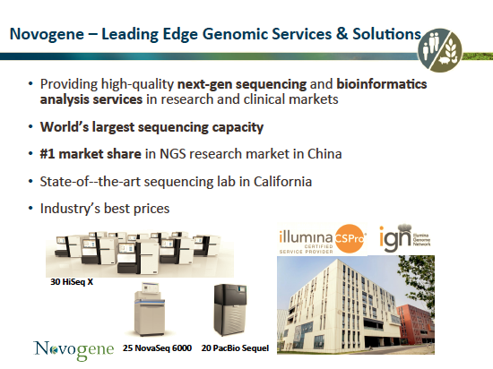
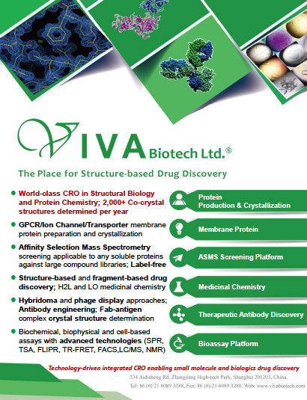
Currently, R&D Systems, Tocris Bioscience, Novus Biologics, and Protein Simple will serve as the flagship brands in Bio-Techne's life science portfolio.
R&D Systems entered the field of biotechnology early, becoming the first company to commercially market the multifunctional cytokine TGF-beta 1.Tocris is the leading supplier of novel, exclusive small molecules and peptides for life science research. ProteinSimple develops and commercializes proprietary systems and consumables for protein analysis that ultimately help reveal new insights into the true nature of proteins.

Conference Organizing Committee
President: Huaina Li
Executive Vice President: Kevin Shao
Past President: Jinsong Ni
Committee | Positions and Names
Advisory | Chair: Ying Zhao  Members: Hengchu Cao, Goran Matijasevic, Fred Ouyang, Yan-bo Yang, Fangang Zeng, Zhongping Chen, Peter Chen, Dongping Lin, Jinsong Ni, Jinghui Li, Paul DeRidder
Treasurer | Chair: Vivian Chang  Members: Emily (Xuning) Guo
Secretary | Chair: Fred Ouyang  Members: Ling Lin, Bin Tian
Los Angeles | Chair: Ji-Cheng (Jason) Wang  Members: Daisy Ni, Yunguang Tong
Career Development | Chair: Yan-Bo Yang  Members: Yinong Xie
Communication | Chair: Ling Lin; Vice Chair: Eric Zhou  Members: Daisy Ni, Lucheng Shao
Fund Raising | Chair: Qing Zhou; Vice Chair: Alex Lu  Members: Libin Cui, Kevin Shao, Jinping Wan, Yanbo Yang, Huaina Li, Bruce Liu
Event Logistics | Chair: Haojun Fu  Members: Gregory Gong, Lucy Zhou, Qing Zhou
Events Registration | Chair: Lucheng Shao  Members: Emily Guo, Bing Li, Richard Chang, Sharon Yang, Hugang Ren, Junze Liu
China Connection | Chair: Zhen Zhu  Member: Fangjing Wang, Ji-Cheng (Jason) Wang, Yinong Xie, Libin Cui, Richard Chang
Membership Development | Chair: Jie Shen  Member: Byron Chen, Fangjing Wang, Alex Lu, Dan Duan, Boya Song
Event Photography | Chair: Lucy Zhou  Member: Quanyin Gao, Bruce Liu
Medical Device Discussion Group (MDDG) | Chair: Kevin Shao  Member: Hugang Ren, Haojun Fu, Lu Chen, Lingfeng Yu
Webmaster | Chair: Zhen Zhu  Member: Fangjing Wang, Hugang Ren

